

Bootstrap - 4

Study of classes & properties

Yash Lathiya

|  |  |  |  |
| --- | --- | --- | --- |
| Sr No. | Topic | Date | Page No. |
|  |  |  |  |
| 1 | Detailed Study of Bootstrap | 31/07/2023 | 2 |

Table of Contents

Bootstrap

* Bootstrap 5 is the newest version of bootstrap framework.
* Bootstrap 5 works on flex display while Bootstrap 4 works on fluid display as default, that’s why Bootstrap 5 is more responsive compared to Bootstrap 4.
* Bootstrap 5 is switched to javascript instead of jQuery which was used in previous versions.

Advantage of Bootstrap

* Easy to use
* Responsive feature
* Mobile first approach
* Compatible to browser

Structure of Bootstrap

* Bootstrap contains CSS, Javascript & different fonts.

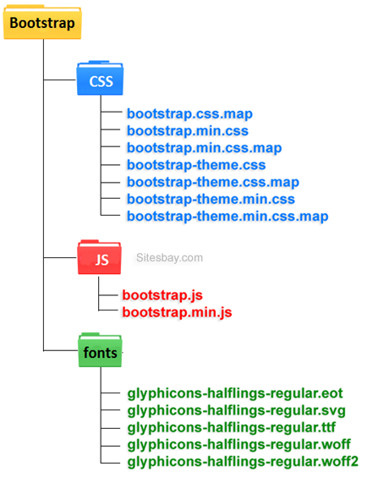

* Grid Classes

Bootstrap grid divides screen in 12 columns, programmer can display content as they want. we can define how many columns should contain by container, if we don't define it, the grid automatically divides them in equal partitions.

* Container

Responsive container of fixed-width.

* Container-fluid

Full Width container.

* P – padding
* pt : top padding (likewise for bottom, left & right)
* border
* .bg-primary, .bg-success, .bg-info, .bg-warning, .bg-danger, .bg-secondary, .bg-dark , .bg-light
* Size of container : .sm .md .lg .xl
* Typography

Bootstrap 4 uses a default size of 16 px and line height 1.5

.display-1 (Bigger Font Size)

.display-2

.display-3

.display-4 (Smaller Font Size)

.mark : highlight text

.font-weight-bold

.font-italic

.text-black-50 (here 50 is opacity)

* Icons

Bootstrap 4 has not its own library of icons, if we want to use - we can use font-awosome or google material design library.

* .media (for adding media elements like image and videos )
* .media-body
* .d-flex (display-flex)
* .d-none (display-none)

There are several more significant classes in bootstrap 4 like Navbar, carousel, jumbotron, card, form, etc.. for showing it’s implementation directly demo is prepared.